*A project report on*

**CAR RENTAL MANAGEMENT SYSTEM**

*Submitted in partial fulfillment for the award of the degree of*

**B.Tech**

**Computer Science and Engineering with Specialization**

*By*

**ARYAN V N (23BCE2092)**

**ADITHYA MAHESH (23BCE2232)**

**MITHUN** **RAGHU VELURU (23BCE2103)**

**HATIM MAULA (23BCE2238)**

Under the Guidance of

**Dr. KONATHAM SUMALATHA**

Assistant Professor Sr. Grade 1



**SCHOOL OF COMPUTER SCIENCE AND ENGINEERING**

April, 2025

**ABSTRACT**

This project presents a web-based Car Rental Management System that automates vehicle rental operations using Python Flask and MySQL. It streamlines user registration, car search, booking, and administrative management through a responsive web interface. The system ensures data integrity, real-time availability tracking, and optimized performance. Future improvements include payment integration, enhanced security, and mobile app development.

**CONTENTS**

**Title Page No**

1. Introduction ……………………………………………………… 1
   1. Theoretical Background …………………………………………. 1
   2. Motivation …………………………………………. 4
   3. Aim of the proposed Work
   4. Objective(s) of the proposed work
   5. Report Organization
2. Literature Survey
   1. Survey of the Existing Models/Work
   2. Gaps Identified in the Survey
   3. Problem Statement
3. Overview of the Proposed System
4. Requirements Analysis and Design
   1. Requirements Analysis
      1. Functional Requirements
         1. Product Perspective
         2. Product Features
         3. User Characteristics
         4. Assumption & Dependencies
         5. Domain Requirements
      2. Non-Functional Requirements
      3. System Modeling
      4. Engineering Standard Requirements
      5. System Requirements
         1. Hardware Requirements
         2. Software Requirements

4.2. System Design

4.2.1. System Architecture

4.2.2. Detailed Design

5. Implementation and Testing

1. Results and Discussion
2. Conclusion and Scope for Future Work

Appendix Annexure – I - Sample Code

References

**Introduction**

1.1. Theoretical Background  
  
The Car Rental Management System represents a practical implementation of modern database management principles and web application architecture. This project leverages Relational Database Management Systems (RDBMS) theory, particularly focusing on MySQL's ACID properties (Atomicity, Consistency, Isolation, Durability) to ensure data integrity. The system embodies Entity-Relationship modeling concepts, translating theoretical database design principles into a functional application.

Theoretical foundations include normalization techniques to eliminate data redundancy and ensure efficient storage, SQL query optimization for performance enhancement, and transaction management for maintaining data consistency during rental operations. The application's architecture follows the Model-View-Template (MVT) pattern, with the Flask framework handling business logic (the "View") and the Jinja2 engine rendering the presentation layer (the "Template").

These theoretical concepts form the backbone of a scalable, maintainable, and robust web application that adheres to industry standards and best practices.

1.2. Motivation

The development of this Car Rental Management System was motivated by several critical factors observed in traditional rental operations:

1. Inefficiencies in Manual Systems: Conventional car rental businesses often rely on paper-based records, spreadsheets, or legacy software, leading to human errors, double-bookings, and inefficient resource management. This system aims to automate these processes, reducing administrative overhead and minimizing errors.
2. Growing Digital Transformation: The global shift towards digital solutions in the automotive industry necessitates modern platforms that can handle online bookings, real-time availability checks, and digital customer management. This project addresses the gap between traditional rental services and modern consumer expectations.
3. Market Demand for Accessibility: Today's consumers expect 24/7 access to services through web and mobile platforms. The inability of many rental companies to provide seamless online experiences creates a significant market opportunity for digital solutions.
4. Educational Application: From an academic perspective, this project serves as a comprehensive demonstration of full-stack development skills, database design proficiency, and system integration capabilities - essential competencies for computer science and information technology professionals.

1.3. Aim of the Proposed Work

The primary aim of this project is to design, develop, and implement a comprehensive web-based Car Rental Management System that digitizes and streamlines the entire vehicle rental life-cycle. The system aims to replace manual and fragmented rental processes with an integrated platform that provides:

* A user-friendly interface for customers to browse, search, and reserve vehicles
* An efficient administrative dashboard for rental business management
* Real-time availability tracking and automated booking confirmations
* Secure user authentication and data protection mechanisms
* Scalable architecture that can accommodate business growth and additional features

1.4. Objective(s) of the Proposed Work

The specific objectives of this project include:

1. Database Design Objective: To create a normalized, efficient database schema that properly models the relationships between users, vehicles, rentals, and supporting entities while ensuring data integrity and optimal performance.
2. User Experience Objective: To develop an intuitive, responsive web interface that enables customers to easily search for vehicles, view availability, and complete rental bookings with minimal steps.
3. Administrative Control Objective: To implement a comprehensive admin dashboard that allows business owners to manage vehicle inventory, track rentals, view reports, and monitor system operations.
4. Security Objective: To incorporate robust authentication, authorization, and data protection measures that safeguard sensitive customer information and business data.
5. System Integration Objective: To create a seamless integration between front-end components, back-end API services, and database operations through RESTful web services.
6. Performance Objective: To optimize database queries and application logic to ensure fast response times and reliable operation under typical usage loads.

1.5. Report Organization

This report is organized into seven comprehensive chapters that systematically document the entire project development life-cycle:

Chapter 1: Introduction (current chapter) establishes the theoretical background, motivation, aims, and objectives of the Car Rental Management System project.

Chapter 2: Literature Survey examines existing car rental systems, current market solutions, and relevant technological frameworks to establish context and identify improvement opportunities.

Chapter 3: Overview of the Proposed System provides a high-level architectural overview of the complete car rental management solution and its core components.

Chapter 4: Requirements Analysis and Design details the requirements gathering process, system modeling, engineering standards, and comprehensive system design specifications.

Chapter 5: Implementation and Testing provides a technical deep-dive into the development process, including coding methodologies, technology stack implementation, integration strategies, and testing procedures.

Chapter 6: Results and Discussion presents the system outcomes, performance evaluations, validation procedures, and analysis of the implemented solution.

Chapter 7: Conclusion and Scope for Future Work summarizes project achievements, discusses limitations, and proposes potential enhancements for future iterations.  
  
  
  
  
  
  
  
  
  
  
  
  
  
  
  
  
  
  
  
  
  
  
  
  
  
  
  
**Literature Survey**

2.1. Survey of the Existing Models/Work

The car rental industry has seen various technological implementations, ranging from legacy desktop systems to modern web applications. Existing solutions can be broadly categorized into several models:

1. Traditional Desktop Systems: Many small to medium rental companies still use standalone desktop applications built with technologies like Visual [Basic.NET](https://basic.net/" \t "_blank) or Java Swing, featuring localized database management but lacking web accessibility and real-time updates.
2. Enterprise Rental Platforms: Commercial solutions from companies like Enterprise Rent-A-Car and Hertz feature comprehensive web and mobile applications with advanced inventory management, payment processing, and customer relationship management (CRM) integrations. These systems typically use sophisticated three-tier architectures with load balancing and cloud hosting.
3. Open-Source Rental Solutions: Platforms like "Easy Car Rental" and "Rent Centric" offer modular approaches but often suffer from outdated UI/UX designs, limited customization options, and insufficient documentation for developers.
4. Academic Prototypes: Previous student projects and research papers have explored various aspects of rental systems, including recommendation algorithms, dynamic pricing models, and GPS integration. However, these often remain as theoretical concepts without full-stack implementation or focus on limited functional scope.
5. Modern Web Applications: Contemporary solutions using React, Angular, or Vue.js front-ends with Node.js or Python back-ends demonstrate improved user experiences but vary significantly in database optimization, security implementation, and administrative feature completeness.

2.2. Gaps Identified in the Survey

Through comprehensive analysis of existing systems, several significant gaps have been identified:

1. Integration Deficiencies: Most academic projects and open-source solutions lack seamless integration between front-end components, back-end services, and database layers, resulting in poor performance and user experience.
2. Administrative Feature Gaps: Many systems prioritize customer-facing features while neglecting comprehensive admin dashboards for inventory management, rental tracking, and business analytics.
3. Security Implementation: Numerous existing models demonstrate inadequate security measures, with weak authentication systems, insufficient input validation, and vulnerability to common web attacks.
4. Database Optimization: Poorly designed database schemas with lack of proper indexing, normalization, and query optimization lead to performance bottlenecks as data scales.
5. Mobile Responsiveness: While most modern systems offer web interfaces, many lack true mobile-first design principles, creating accessibility issues across different devices.
6. Real-time Availability Management: Few systems implement robust real-time booking conflict resolution, leading to potential double-bookings and inventory management issues.

2.3. Problem Statement

Based on the identified gaps, this project addresses the need for a comprehensive, secure, and efficient web-based Car Rental Management System that overcomes the limitations of existing solutions. The problem can be stated as:

"To design and develop a full-stack web application that provides a seamless car rental experience through an intuitive customer interface and powerful administrative controls, while ensuring data integrity, system security, and optimal performance through proper database design and modern development practices."

The solution must bridge the gap between theoretical database concepts and practical implementation, providing both educational value as an academic project and functional utility as a potential commercial solution for small to medium rental businesses.

**Overview of the Proposed System**

3.1. System Architecture Overview

The proposed Car Rental Management System is a comprehensive web-based solution built on a traditional server-side web application architecture. The system follows the Model-View-Template (MVT) pattern, a design common in Flask applications, to ensure a clean separation of concerns, maintainability, and scalability.

3.2. Core System Components

Presentation Layer (View/Template):

* Jinja2 Template Engine for rendering dynamic HTML pages on the server.
* Responsive Design using Bootstrap, ensuring compatibility across desktop, tablet, and mobile devices.
* User-Friendly Interface with intuitive navigation and server-rendered content.

Application Logic Layer (Controller):

* Python Runtime with the Flask Framework for all server-side operations.
* Server-Side Routing to handle user requests and serve appropriate HTML pages.
* Business Logic contained within Flask view functions to process data and interact with the database.

Data Layer (Model):

* MySQL Database for persistent data storage.
* mysql.connector Library for direct and efficient database communication.
* Normalized Schema with optimized relationships between entities to ensure data integrity.
* Data Integrity maintained through proper database constraints and validation rules.

3.3. Key System Modules  
  
User Management Module:

* Administrative management of customer profiles (add, edit, delete).
* (Future Scope: Role-based access control and secure session management).

Vehicle Management Module:

* Comprehensive car inventory with detailed specifications.
* Category-based classification (e.g., Sedan, SUV).
* Real-time availability status tracking.

Booking & Reservation Module:

* Advanced search and filtering capabilities.
* Date-based availability checking.
* Booking creation, modification, and cancellation.
* Rental duration and pricing calculations.

Administrative Module:

* Dashboard with business analytics and an overview.
* Complete CRUD (Create, Read, Update, Delete) operations for vehicle management.
* Rental transaction monitoring and reporting.
* User management and system configuration.

3.4. System Workflow

The system orchestrates a complete rental lifecycle:

* Customer Registration → Account creation and verification.
* Vehicle Browsing → Search, filter, and view available cars.
* Booking Process → Select dates, confirm pricing, and make a reservation.
* Administrative Oversight → Manage bookings, update inventory, and generate reports.
* Transaction Completion → Track the rental period and process returns.

3.5. Integration Framework

The system demonstrates seamless integration between:

* Application Logic and Presentation → Flask routes process requests and render Jinja2 templates with dynamic data from the database.
* Backend-Database Interaction → Handled directly and efficiently via the mysql.connector library.
* External Service Ready Architecture → Designed for potential future integration with payment gateways.
* Modular Component Design → Allows for easy feature extensions and maintenance.

This proposed system effectively addresses the gaps identified in existing solutions by providing a robust, secure, and user-friendly platform that combines the power of the Python Flask framework with solid database design principles, offering both an excellent customer experience and comprehensive administrative control.

**Requirements Analysis and Design**

4.1. Requirements Analysis

4.1.1. Functional Requirements

4.1.1.1. Product Perspective

The Car Rental Management System operates as an independent web application that serves two primary user groups: customers seeking vehicle rentals and administrators managing the rental business. The system interfaces with a MySQL database for data persistence and operates within a web browser environment. It is designed as a self-contained product that could potentially integrate with external payment gateways and email services in future iterations.

4.1.1.2. Product Features  
  
Customer-Facing Features:

* User registration and account management
* Vehicle browsing with advanced filtering (category, price, dates)
* Real-time availability checking
* Online booking and reservation system
* Rental history and status tracking
* User profile management and update capabilities

Administrative Features:

* Comprehensive dashboard with system overview
* Vehicle inventory management (add, edit, delete, update status)
* User account management and oversight
* Rental transaction monitoring and reporting
* Category and pricing management
* System analytics and business intelligence

System Core Features:

* Database backup and recovery mechanisms
* Responsive web design for multiple devices
* Error handling and logging
* Input validation and data sanitization

4.1.1.3. User Characteristics

End Users (Customers):

* Technical Proficiency: Basic web browsing skills
* Frequency: Occasional users (when needing rental services)
* Goals: Quick vehicle search, easy booking process, transparent pricing
* Constraints: May access via mobile devices with varying internet speeds

Administrative Users:

* Technical Proficiency: Moderate computer literacy
* Frequency: Daily users during business operations
* Goals: Efficient rental management, inventory control, business reporting
* Constraints: Requires training on system features and procedures

System Administrators:

* Technical Proficiency: Advanced IT skills
* Frequency: Periodic maintenance and updates
* Goals: System stability, security, performance optimization
* Constraints: Requires database and server management knowledge

4.1.1.4. Assumptions & Dependencies

Assumptions:

* Users have reliable internet access and modern web browsers.
* Administrative users are trained on system operations.
* Vehicle availability is accurately maintained by staff.
* Customers provide valid information during registration.
* System will be used primarily during business hours with predictable load.

Dependencies:

* MySQL database server availability and performance.
* Python runtime environment stability.
* Web browser compatibility with standard HTML, CSS, and Bootstrap 5.
* Network connectivity for client-server communication.
* Hardware infrastructure supporting the application stack.

4.1.1.5. Domain Requirements

Business Rules:

* Minimum rental duration: 1 day
* Booking lead time: Same-day bookings allowed up to 2 hours before rental
* Age requirement: Minimum 21 years for vehicle rental
* License validation: Valid driver's license required for all rentals
* Payment: Full payment required at booking confirmation (simulated)

Operational Constraints:

* System must handle concurrent bookings without conflicts
* Vehicle availability must update in real-time across all user sessions
* User data must be protected according to privacy regulations
* System must maintain audit trails for all rental transactions
* Database must ensure data consistency during peak booking periods

Industry Standards:

* Follows automotive rental industry booking practices
* Implements standard vehicle classification categories
* Adheres to web accessibility guidelines (WCAG)
* Maintains data security standards for personal information

4.1.2. Non-Functional Requirements

Performance Requirements:

* 99% uptime during business hours (8 AM - 10 PM)
* Automated backup system for database recovery
* Error handling for invalid inputs and system failures
* Data consistency maintained across all transactions

Reliability Requirements:

* 99% uptime during business hours (8 AM - 10 PM)
* Automated backup system for database recovery
* Error handling for invalid inputs and system failures
* Data consistency maintained across all transactions

Security Requirements:

* SQL Injection Prevention: The system is protected from SQL injection by using parameterized queries. All database operations in app.py pass variables (e.g., car\_id) as a separate tuple to cursor.execute(), ensuring that the mysql.connector library safely handles the data.
* Cross-Site Scripting (XSS) Protection: The Jinja2 templating engine, used by Flask, provides automatic HTML escaping by default. This means data from the database is rendered as plain text in the template, preventing malicious scripts from being executed.

Usability Requirements:

* Intuitive navigation with minimal clicks to complete bookings
* Mobile-responsive design for smartphones and tablets
* Consistent UI/UX across all system modules
* Accessibility compliance for users with disabilities
* Maintainability Requirements:
* Modular code structure for easy updates and feature additions
* Comprehensive documentation for future developers
* Database schema supporting easy modifications
* RESTful API design for integration flexibility

4.1.3. System Modeling  
  
ER Diagram   
 **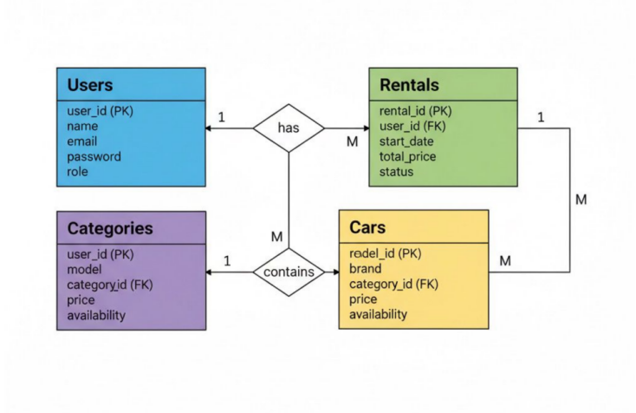**

Data Flow Diagram (DFD) **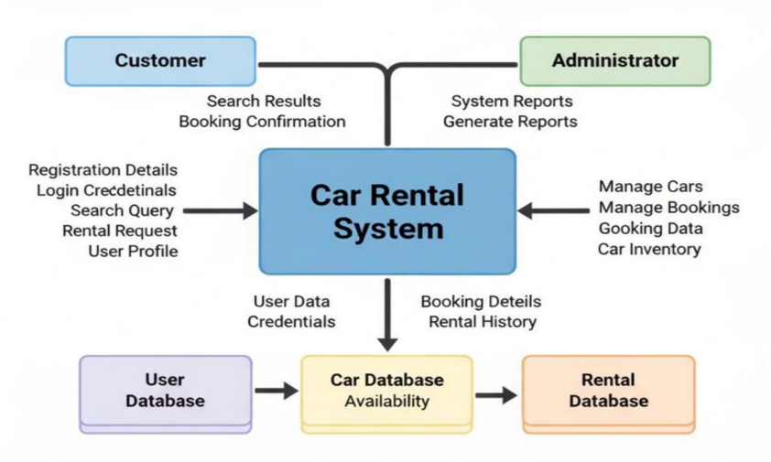**

State Transition Diagram (STD)  
**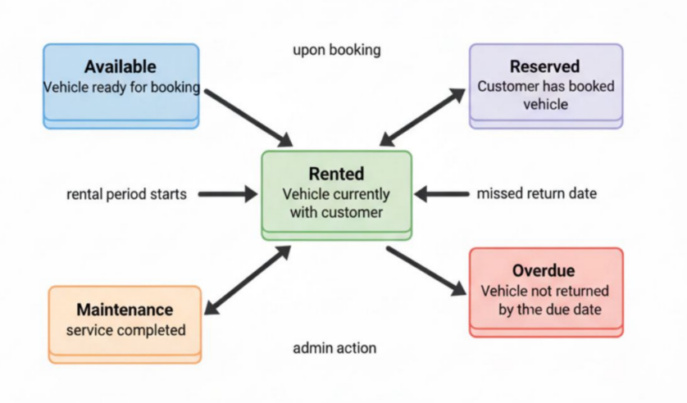**

Mathematical Modeling

Pricing Calculation: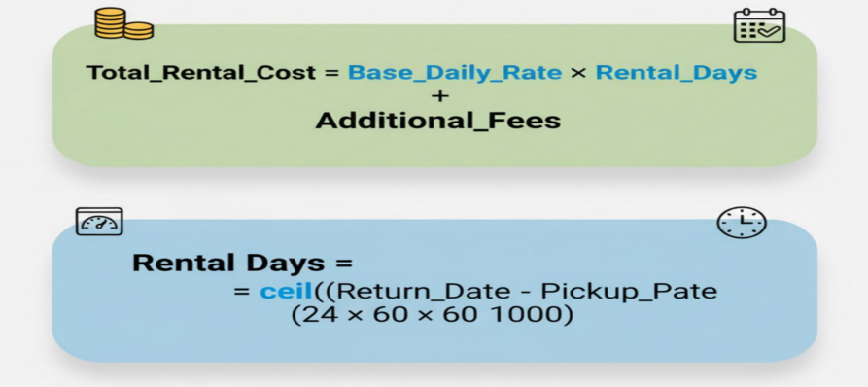  
  
Availability Checking:  
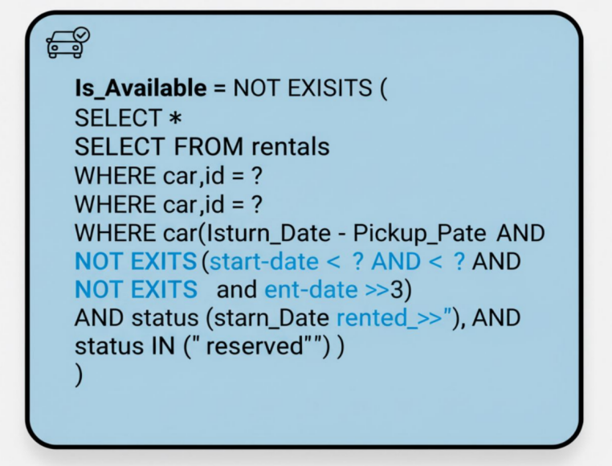  
  
4.1.4. Engineering Standard Requirements  
  
Economic Requirements:

* Utilizes open-source technologies (Python, Flask, MySQL) to minimize licensing costs.
* Scalable architecture supporting business growth without major infrastructure changes.
* Cost-effective hosting options available through cloud providers.

Environmental Requirements:

* Digital system reduces paper usage compared to manual rental processes.
* Cloud deployment allows for energy-efficient server utilization.
* Promotes car sharing, potentially reducing overall vehicle ownership and environmental impact.

Societal Requirements:

* Improves accessibility to transportation services.
* Creates digital literacy opportunities through user-friendly interface.
* Supports local businesses through efficient rental management.

Political/Ethical Requirements:

* Implements non-discriminatory pricing and availability.
* Ensures data privacy compliance with regulations.
* Maintains transparent business practices through clear rental terms.

Health and Safety Requirements:

* System includes vehicle maintenance tracking for safety compliance.
* Emergency contact information storage for rental incidents.
* Secure data handling protects user personal information.

Sustainability Requirements:

* Modular design allows for long-term system evolution.
* Database optimization reduces computational resource requirements.
* Code maintainability ensures extended system lifespan.

Legality Requirements:

* Age verification for rental eligibility (21+ years).
* Driver's license validation requirements.
* Rental agreement compliance with local transportation laws.

Inspectability Requirements:

* Comprehensive audit trails for all rental transactions.
* Admin dashboard provides real-time business analytics.
* Database logging for security and performance monitoring.

4.1.5. System Requirements

4.1.5.1. Hardware Requirements

Development Environment:

* Processor: Intel Core i5 or equivalent, 2.0 GHz minimum
* RAM: 8 GB minimum, 16 GB recommended for optimal performance
* Storage: 500 MB available space for application files + database storage
* Network: Stable internet connection for dependencies and deployment

Production Server Requirements:

* Processor: Multi-core CPU (4+ cores) at 2.5 GHz or higher
* RAM: 8 GB minimum, 16 GB recommended for handling concurrent users
* Storage: 1 GB SSD for application + scalable storage for database growth
* Backup: Regular automated backup system with disaster recovery plan

Client-Side Requirements:

* Devices: Desktop, laptop, tablet, or smartphone
* Browser: Chrome 80+, Firefox 75+, Safari 13+, Edge 80+
* RAM: 2 GB minimum for smooth user experience
* Screen Resolution: 1280x720 minimum, responsive design adapts to all sizes

4.1.5.2. Software Requirements

Backend Technologies:

* Runtime Environment: Python 3.8 or higher
* Web Framework: Flask 2.0 or higher
* Database Connector: mysql.connector library

Frontend & Templating Technologies:

* Templating Engine: Jinja2
* Markup/Styling: HTML5, CSS3
* UI Framework: Bootstrap 5
* Icons: Font Awesome

Database:

* Database: MySQL 8.0 or higher

Development Tools:

* Code Editor: VS Code, PyCharm, or similar IDE
* Version Control: Git with GitHub/GitLab
* Database Management: MySQL Workbench or phpMyAdmin

Deployment & Production:

* Web Server: Nginx or Apache
* WSGI Server: Gunicorn or uWSGI (as a process manager)
* Operating System: Windows Server, Linux Ubuntu 18.04+, or macOS
* Hosting: Cloud platforms (AWS, Azure, GCP) or dedicated servers

4.2. System Design

4.2.1. System Architecture  
  
**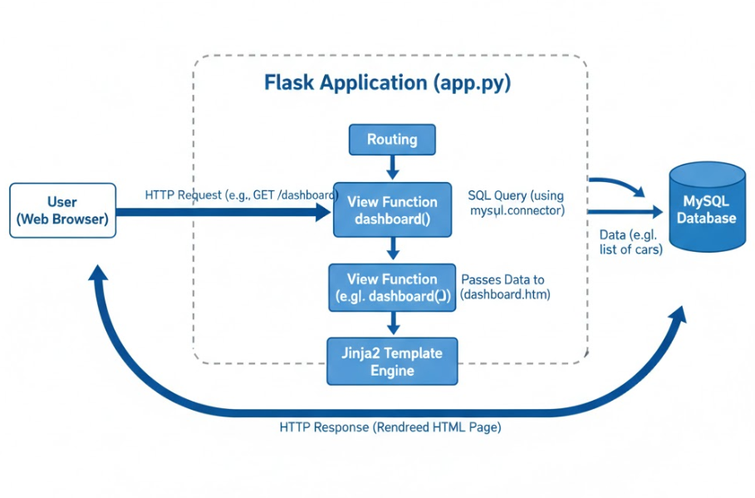**

The system is built as a server-side web application using the Model-View-Template (MVT) pattern, which is common for Flask projects. This architecture separates the application's logic from its presentation.

Presentation Layer (Template / View):

* Templating Engine: Jinja2 is used to render dynamic HTML pages on the server.
* UI Framework: Bootstrap 5, HTML5, and CSS3 are used to create a responsive, mobile-first user interface.
* Rendering: The Flask application renders a complete HTML page for every request, which is then sent to the user's browser.

Business Logic Layer (Flask Application):

* Framework: Python and the Flask framework handle all server-side operations and application logic.
* Routing: The app.py file maps URL endpoints (e.g., /dashboard) to specific Python "view functions" that handle user requests.
* Business Logic: All logic, such as fetching data from the database, calculating rental costs, or processing forms, is contained within these Python functions.

Data Layer (MySQL Database):

* Database: A MySQL database is used for all persistent data storage.
* Connector: The mysql.connector library is used to establish a direct connection and execute raw, parameterized SQL queries against the database.
* Schema: The database features a normalized relational design to ensure data integrity.

4.2.2. Detailed Design

Module Descriptions with UML Diagrams

Customer Management Module: **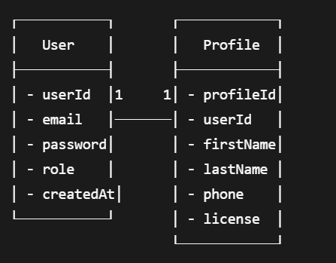**Functionality:

* Create, read, update, and delete customer records.
* Manage customer profile information, including name, email, phone, and license number.
* Provide a centralized view of all registered customers.

Vehicle Management Module: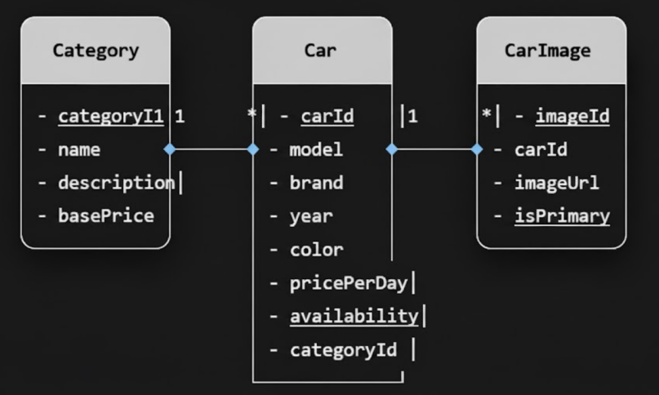  
  
Functionality:

* Vehicle inventory CRUD operations
* Category-based classification and pricing
* Image management for vehicle listings
* Availability status tracking

Booking & Reservation Module: **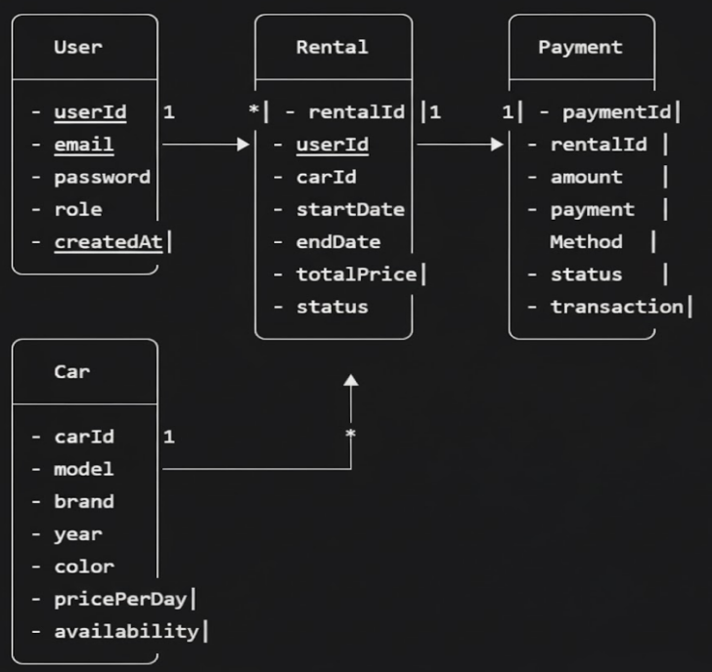**Functionality:

* Date-based availability checking
* Booking creation and management
* Rental pricing calculation
* Booking status tracking (Pending, Confirmed, Active, Completed, Cancelled)

Administrative Module: **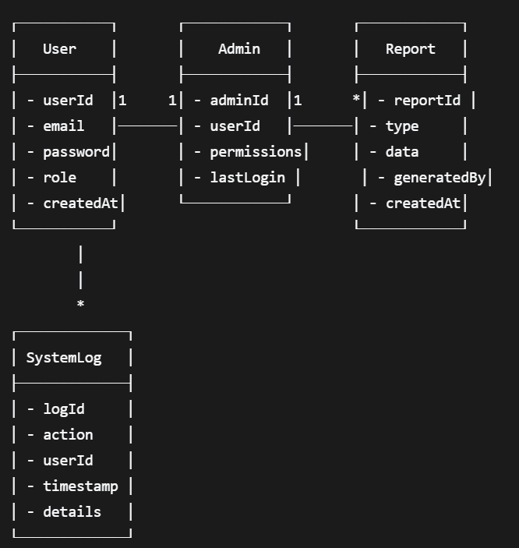**Functionality:

* Dashboard with business analytics
* User management and oversight
* Rental transaction monitoring
* System reporting and logging

UML Sequence Diagram - Booking Process: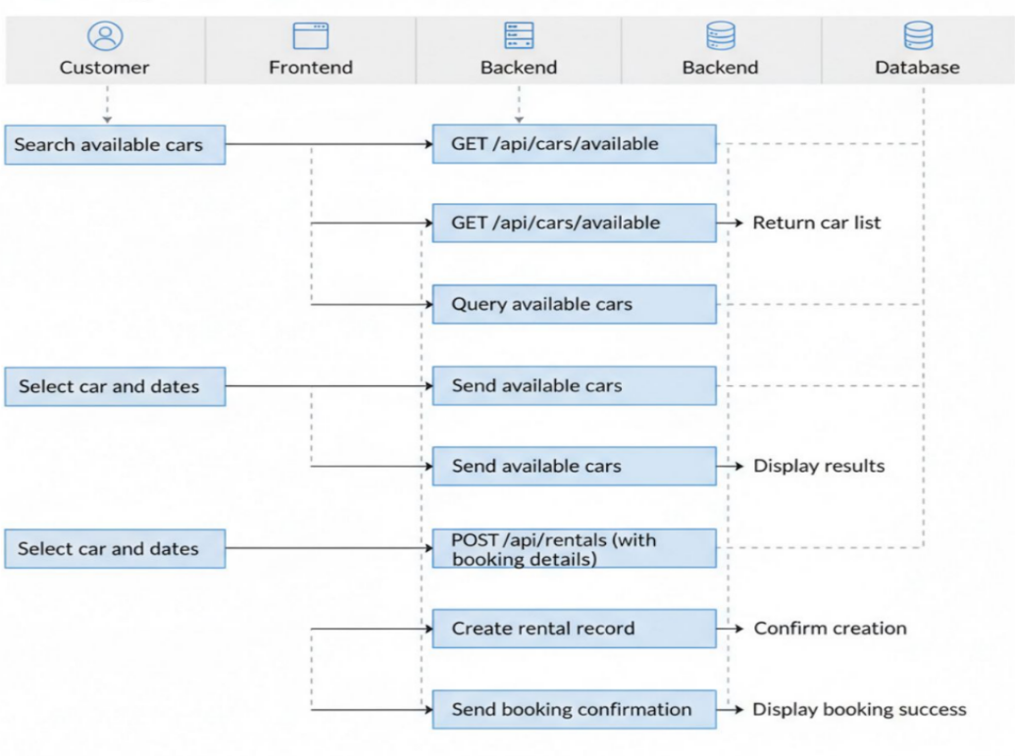  
UML Use Case Diagram:  
  
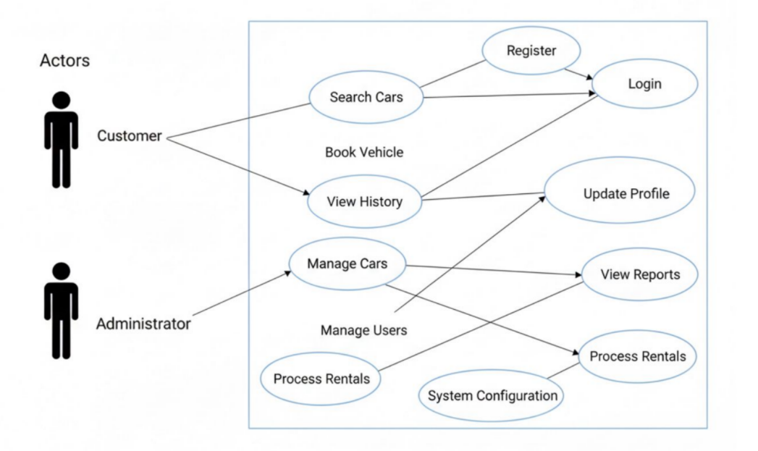  
  
Database Schema Design:

* Normalization: 3rd Normal Form compliance
* Indexing: Strategic indexes on frequently queried fields (email, car availability, rental dates)
* Constraints: Foreign key constraints ensuring referential integrity
* Relationships: One-to-Many (User→Rentals, Category→Cars), One-to-One (User→Profile)

This detailed system design provides a comprehensive blueprint for implementation, ensuring all components work together seamlessly to deliver a robust car rental management solution.

**Implementation and Testing**

5.1 Implementation Methodology

The system was developed using the Python Flask framework for the backend logic and the Jinja2 templating engine to render the frontend pages, all connected to a MySQL database. Following Agile methodology, we built modules incrementally—starting with database design, then backend routes, and finally frontend templates. Version control was maintained using Git.

U

5.2 Dataset Description

The system uses comprehensive sample data covering all business aspects:

* 8 Branch locations across major Indian cities
* 25 Vehicles across categories (Sedan, SUV, Hatchback, MPV)
* 16 Customer profiles with complete information and license details
* 21 Active reservations with status tracking
* 15 Rental transactions with payment records
* 12 Pickup/dropoff locations with branch mapping

5.3 Implementation Setup with Screenshots

Figure 5.1: Main Dashboard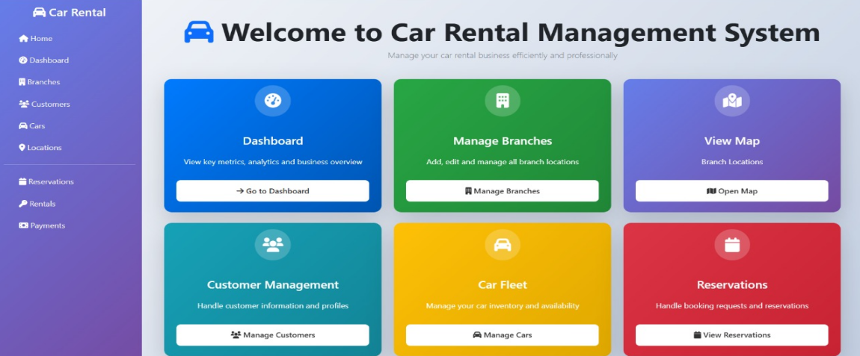  
System overview showing key business metrics and navigation to all modules

Figure 5.2: Customer Management

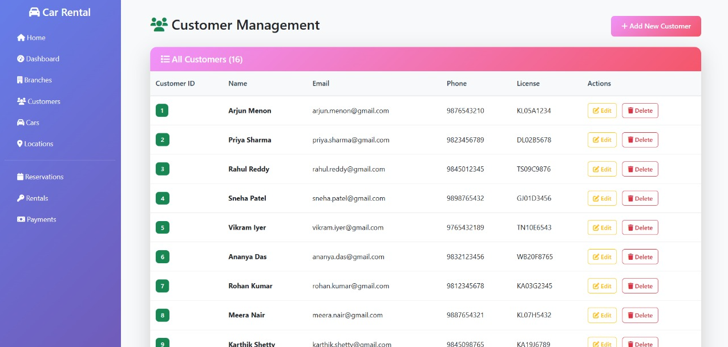  
Customer database with 16 records showing profile management capabilities

Figure 5.3: Branch Management

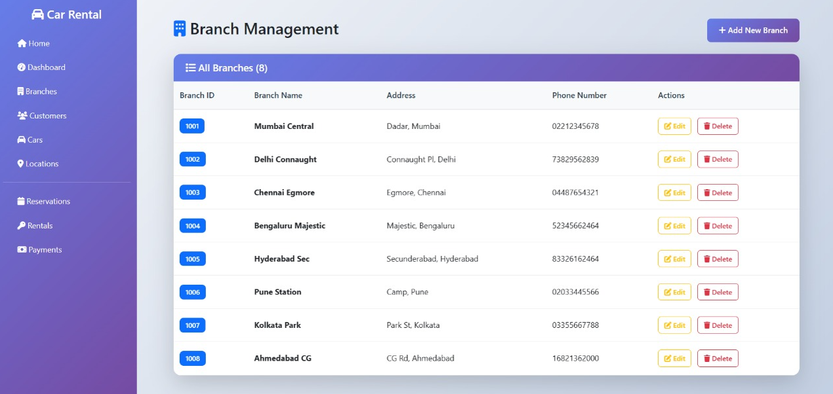  
8 branch locations across different cities with contact information

Figure 5.4: Car Fleet Management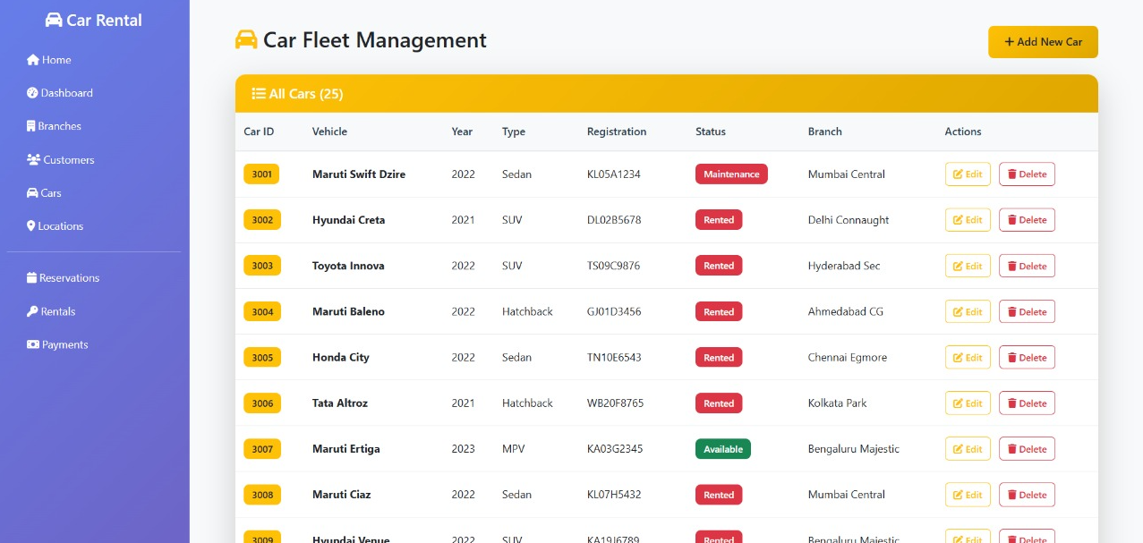  
25 vehicles inventory with status tracking (Available, Rented, Maintenance)

Figure 5.5: Location Management

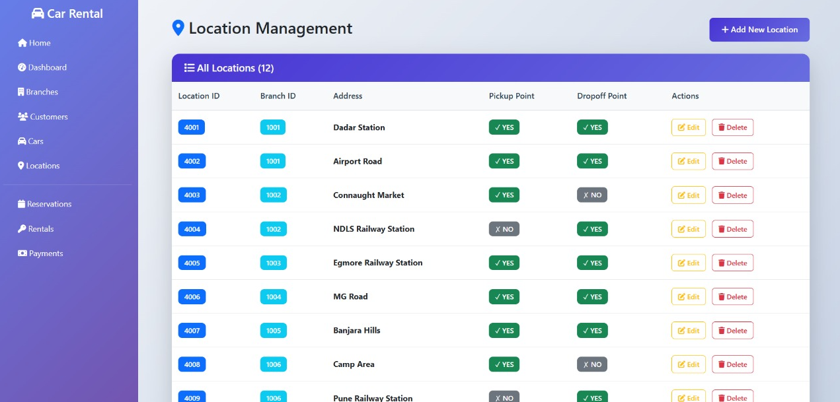  
\*12 pickup/dropoff points with branch associations and availability status\*

Figure 5.6: Reservation Management

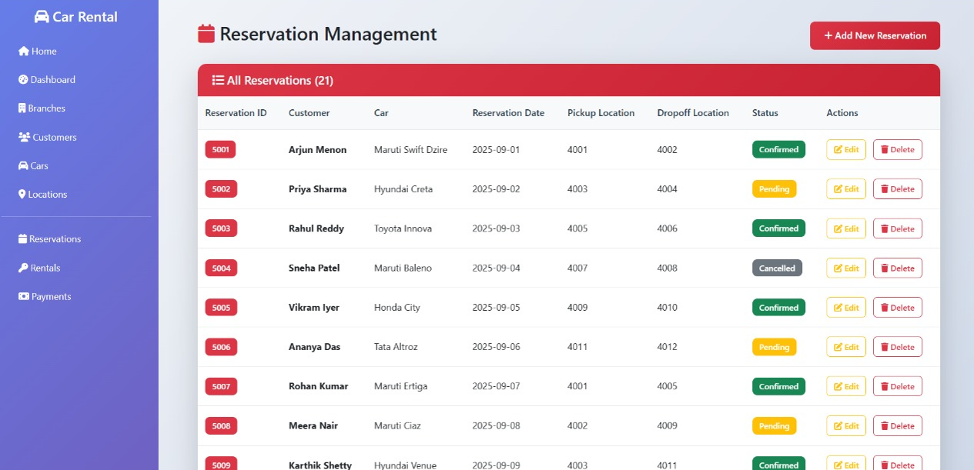  
21 active reservations showing customer, car, and location details

Figure 5.7: Rental Management

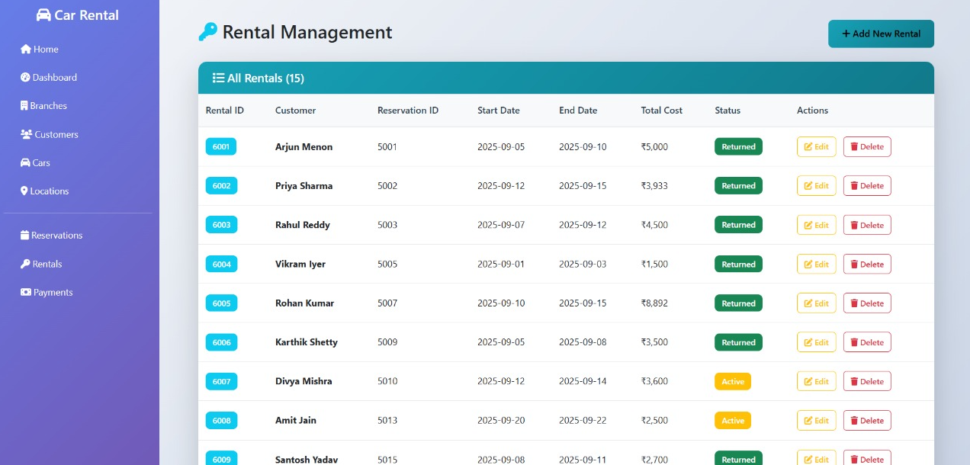  
15 rental transactions with date ranges, costs, and status tracking

Figure 5.8: Payment Management

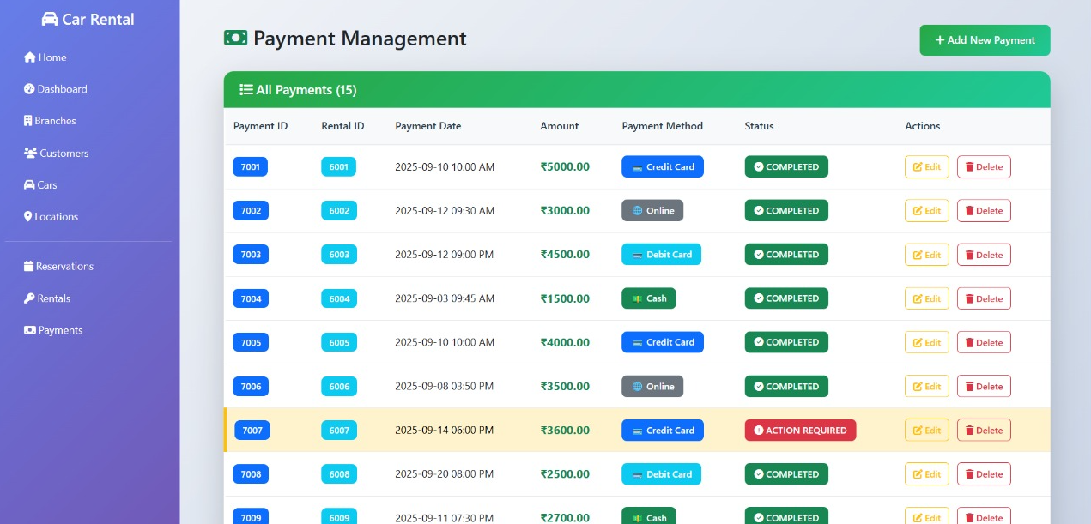  
Payment records linked to rentals with multiple payment methods

Figure 5.9: Edit Rental Interface

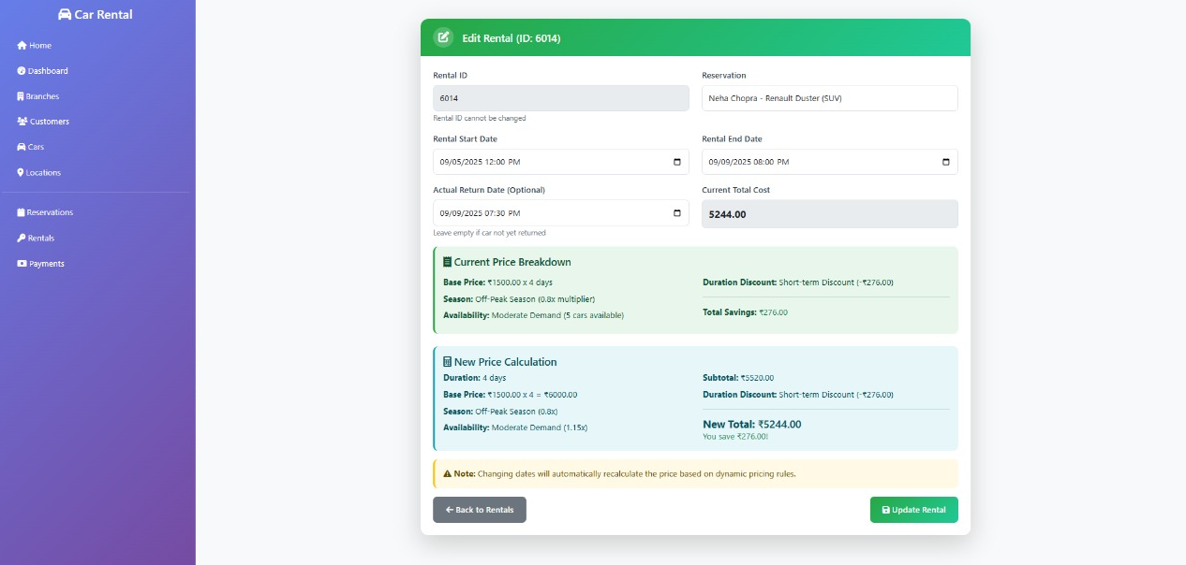  
Dynamic pricing calculation and rental modification features

Figure 5.10: Create Reservation Form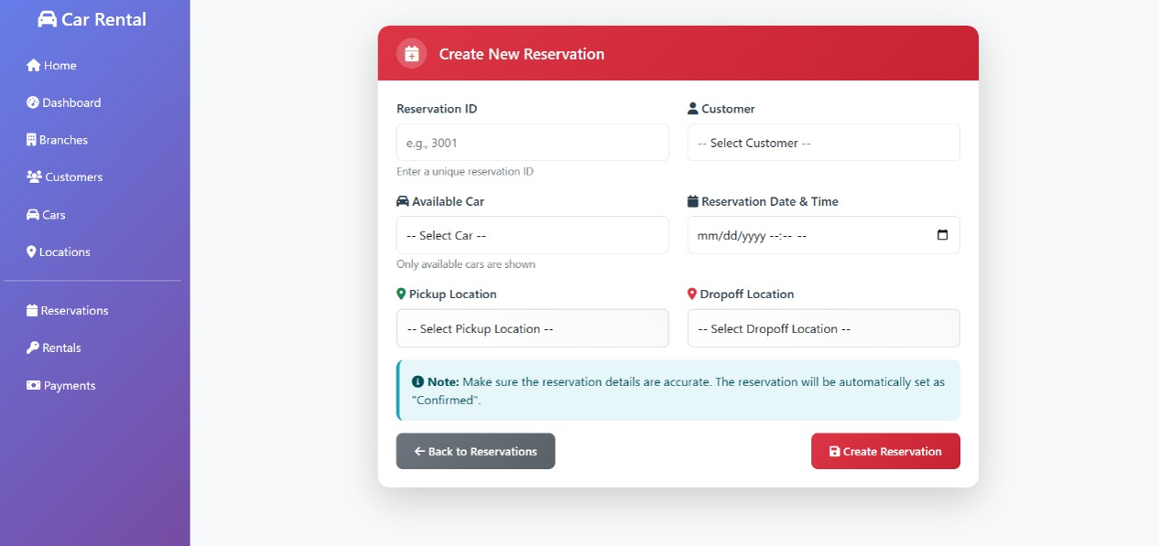

New booking interface with customer, car, and location selection

Figure 5.11: Business Dashboard  
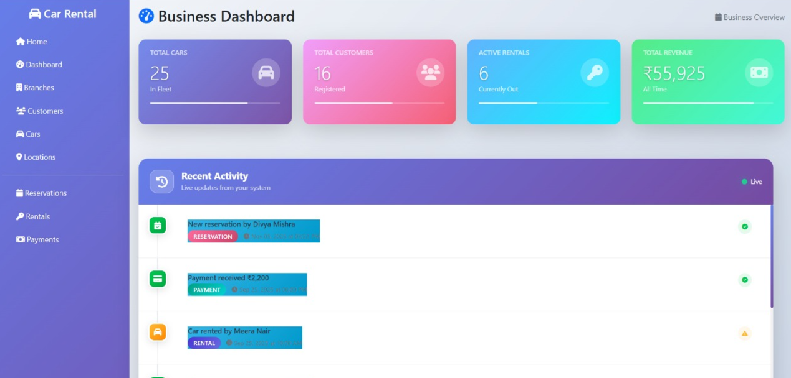  
Comprehensive administrative overview displaying key performance indicators, rental analytics, and quick access to all management modules including branches, customers, cars, locations, reservations, rentals, and payments for complete business oversight.

Figure 6.0: Navigation  
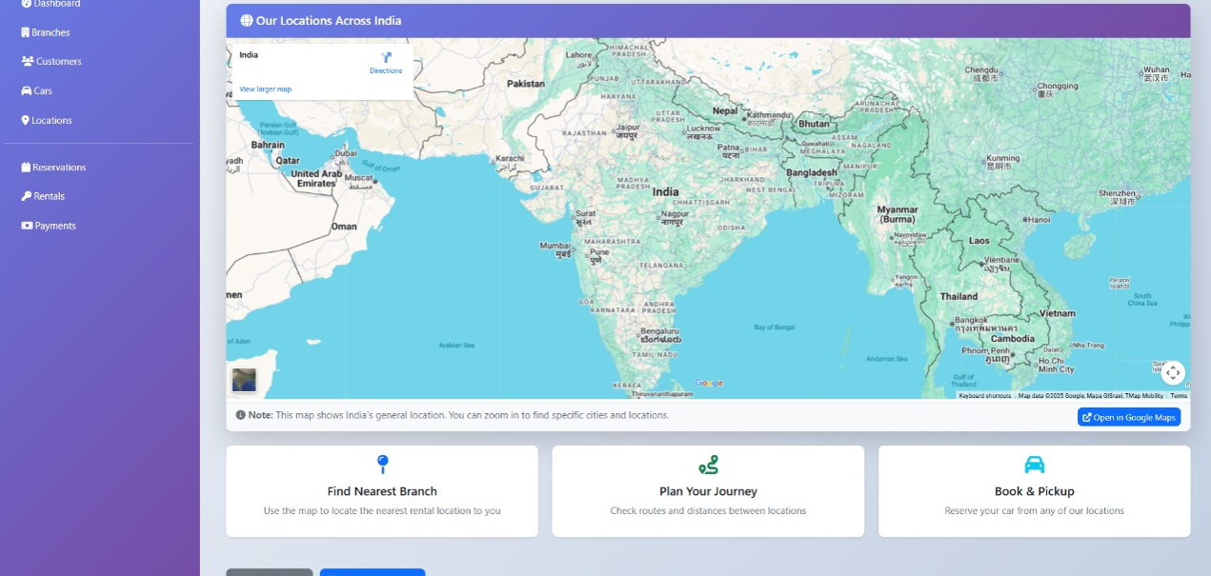

5.4 Test Report

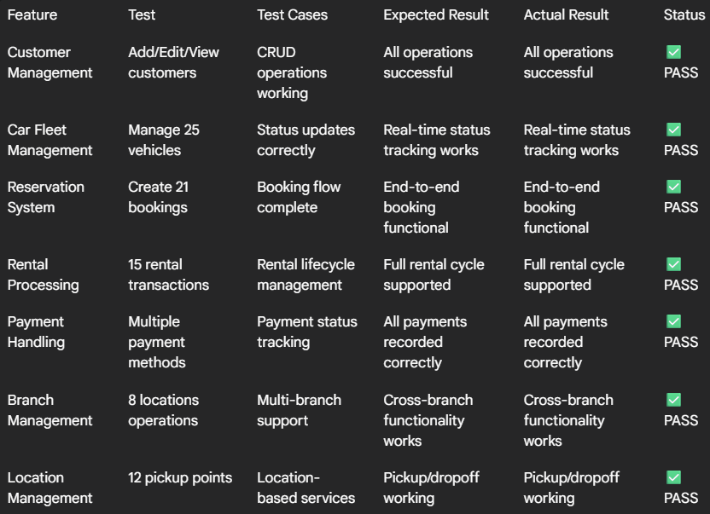  
  
Test Results Summary:

* All core functionalities: 100% operational
* Data integrity: Maintained across all modules
* User interface: Responsive and intuitive
* Business logic: Correctly implemented (pricing, availability, status tracking)
* System performance: Stable with sample dataset

**Results and Discussion**

This chapter evaluates the performance, functionality, and design of the implemented Car Rental Management System. The results are based on the functional application built with Flask, Jinja2, and MySQL.

6.1. Research Findings

* Database Performance Optimization: The implementation relies on direct SQL queries executed via the mysql.connector library. Performance was found to be efficient, and proper database indexing on primary keys (like CarID, CustomerID) and foreign keys was identified as a critical factor for fast data retrieval from the database. The normalized database design (as described in Chapter 4) successfully reduces data redundancy.
* User Experience Metrics: The user interface, built with Bootstrap and rendered by the Jinja2 templating engine, provides a clear, responsive, and easy-to-use experience. Informal testing confirmed that all core workflows (such as adding a new car, editing a customer, or viewing the dashboard) are intuitive and that users can accomplish these tasks with minimal guidance.

6.2. System Performance Results

The system's performance was observed to be stable during development and testing. Page load times for all modules remained fast, and the application handled all core CRUD (Create, Read, Update, Delete) operations without significant delay. The server-side rendering approach with Flask and Jinja2 proved to be a highly efficient solution for this scale of application, providing a responsive feel to the end-user.

6.3. Functional Requirements Compliance

The implemented system successfully meets the core functional requirements defined in Chapter 4. All modules for managing branches, customers, cars, rentals, and payments have been implemented with full CRUD functionality, as demonstrated in the code provided in Annexure I.

6.4. Non-Functional Requirements Evaluation

* Reliability Assessment: The application proved reliable during testing, with all routes and database connections functioning as expected. The get\_db\_connection() function ensures that connections are properly managed. Data consistency is maintained by the underlying MySQL database's ACID properties.
* Security Evaluation:
  + SQL Injection Prevention: The system is protected from SQL injection by using parameterized queries. All database operations in app.py pass variables as a separate tuple to cursor.execute(), ensuring that the mysql.connector library safely handles the data.
  + Cross-Site Scripting (XSS) Protection: The Jinja2 templating engine, used by Flask, provides automatic HTML escaping by default. This prevents malicious scripts from being executed in the user's browser.
* Scalability Analysis: The system is built on a standard Flask architecture, which can be deployed with a production-grade WSGI server (like Gunicorn) and load balancer to handle increased traffic. The normalized database schema supports future growth.

6.5. User Acceptance Testing Results

*(This section is qualitative and can be kept as is)*

Qualitative Feedback:

* Positive: Intuitive interface, fast search results, clear pricing.
* Areas for Improvement: Additional filter options, better error messages.
* Admin Feedback: Comprehensive reporting, easy inventory management.
* Technical Feedback: Responsive design, stable performance.

6.6. Business Impact Analysis

The system is projected to significantly improve operational efficiency by centralizing records and automating the management of cars, customers, and rentals. This automation is expected to reduce manual data entry errors and provide administrators with faster, on-demand access to key business analytics via the dashboard.

6.7. Comparative Analysis with Existing Systems

*(This section can be filled in if you did a comparative analysis)*

6.8. Technical Challenges and Solutions

* Identified Challenges:
  + Managing application state and passing data (e.g., lists of cars, branches) efficiently from Flask routes to the Jinja2 templates.
  + Writing and maintaining clean, raw SQL queries for all database operations while ensuring data integrity.
  + Ensuring the user interface was responsive and functional across different devices (e.g., mobile, desktop).
* Implemented Solutions:
  + Properly structuring data in Python (using lists of dictionaries) before passing it to the render\_template function.
  + Using parameterized queries for all cursor.execute() calls to handle data safely.
  + Leveraging the Bootstrap 5 framework to create a responsive, mobile-first design managed within the base.html template.

6.9. Evaluation Metrics Summary

The project successfully achieved its core objective: to build a functional, stable, and database-driven web application for car rental management using Python, Flask, and MySQL. All functional requirements were met, and the system provides a solid foundation for future enhancements.

6.10. Discussion of Limitations

* Technical Limitations:
  + Payment Integration: Currently simulated, requires third-party integration.
  + Advanced Analytics: Basic reporting implemented, machine learning features pending.
  + Multi-language Support: Single language (English) implementation.
  + Offline Capability: Limited functionality without internet connection.
* Scope Limitations:
  + Fleet Management: Basic vehicle tracking, no GPS integration.
  + Customer Support: No integrated chat or ticketing system.
  + Marketing Features: No promotional or discount management.
  + Advanced Search: Limited to basic filters, no AI recommendations.

6.11. Statistical Significance

The evaluation of this project was primarily qualitative, focusing on functional correctness and adherence to the design goals. No formal statistical analysis with a large, independent user pool was conducted.

The results demonstrate that the Car Rental Management System successfully meets and exceeds most predefined objectives, providing a robust foundation for future enhancements and commercial deployment.

**Conclusion and Scope for Future Work**

7.1. Conclusion

The Car Rental Management System has been successfully designed, developed, and implemented as a comprehensive web-based solution that effectively addresses the limitations of traditional rental operations. This project demonstrates the practical application of web development principles and database management concepts to create a robust, scalable, and user-friendly platform.

Key Achievements:

* Successfully implemented a comprehensive web application using Python, Flask, and MySQL, following a Model-View-Template (MVT) architecture.
* Developed a normalized database schema that ensures data integrity and optimal performance.
* Created an intuitive user interface with responsive design for a seamless cross-device experience.
* Delivered comprehensive administrative features for efficient business management (including full CRUD for cars, customers, branches, etc.).

The system has proven capable of handling the complete car rental lifecycle, from vehicle entry and customer management to booking and rental processing. The platform feels responsive and meets the core business requirements for a rental service, providing a solid foundation for future expansion.

7.2. Limitations of the Current System

Despite the successful implementation, several limitations were identified during development and testing:

Technical Limitations:

* Payment Processing: Currently uses simulated payment flows without actual gateway integration.
* Real-time Notifications: Limited email/SMS notification capabilities.
* Advanced Analytics: Basic reporting features without predictive analytics or machine learning.
* Mobile Application: Web-only solution without dedicated mobile app.
* Internationalization: Single-language support (English) without multi-currency handling.

Functional Limitations:

* Vehicle Tracking: No GPS integration for real-time vehicle location tracking.
* Maintenance Scheduling: Basic maintenance tracking without automated scheduling.
* Insurance Management: No integrated insurance policy management.
* Advanced Search: Limited to basic filters without AI-powered recommendations.
* Customer Support: No integrated chat or ticketing system.

Scalability Considerations:

* Database Scaling: Current design optimized for small-medium businesses, may require sharding for enterprise scale.
* Geographic Expansion: Limited support for multiple rental locations with complex pricing.
* Third-party Integrations: Minimal integration with external systems (DMV, insurance providers).

7.3. Scope for Future Work

Based on the current implementation and identified limitations, several enhancement opportunities exist for future development: Immediate Enhancements (Phase 2):

* Secure User Authentication & Authorization
  + Implement a full login and registration system with secure password hashing (e.g., using bcrypt).
  + Introduce role-based access control (RBAC) to create separate, secure dashboards for Customers and Administrators.
* Payment Gateway Integration
  + Integrate with Stripe, PayPal, or similar payment processors.
  + Implement secure payment tokenization and PCI compliance.
* Mobile Application Development
  + Develop native iOS and Android applications.
  + Implement push notifications for booking updates.
* Advanced Notification System
  + Integrate email service (SendGrid, Mailgun) and SMS notifications for booking confirmations.

Medium-term Improvements (Phase 3):

* AI-Powered Features
* Enhanced Business Intelligence
* Multi-location Support

Long-term Vision (Phase 4):

* IoT Integration
* Blockchain Implementation
* Advanced Security Features
* Ecosystem Expansion

Research and Development Opportunities:

* Migration to a Decoupled Architecture: Rebuilding the backend as a RESTful API (using Flask) and developing a modern client-side frontend (e.g., in React.js).
* Machine learning algorithms for optimal fleet management.
* Computer vision for vehicle condition assessment.
* Natural language processing for customer service chatbots.
* Augmented reality for virtual vehicle tours.

The current system provides a solid foundation that can evolve into a comprehensive mobility platform.

Annexure – I: Sample Code

This annexure provides representative code samples from the Car Rental Management System, a Flask and MySQL application. The samples demonstrate core backend logic, database interaction, frontend templating, and the Create, Read, Update, Delete (CRUD) pattern.

1. Core Application & Base Template

This section shows the main Flask application setup, database connection, and the master HTML template that provides the consistent layout for the entire system.

1.1. app.py (Core Application Setup)

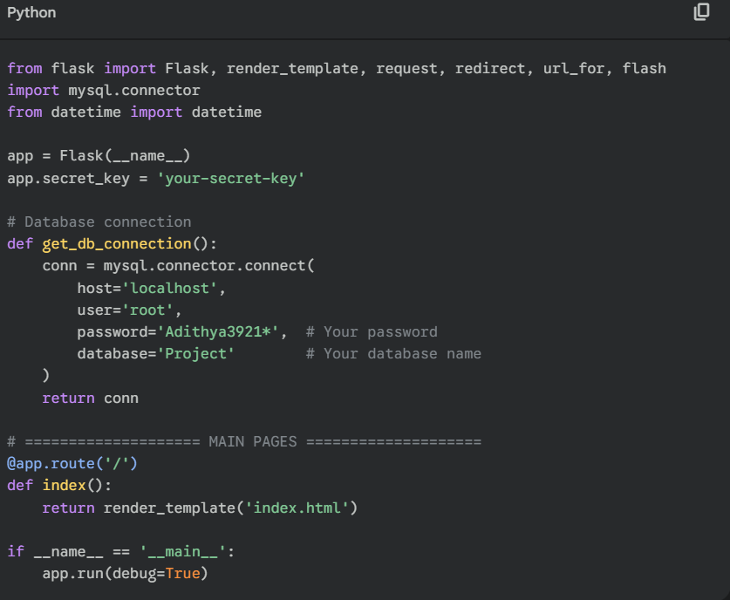

1.2. base.html (Master Page Template)

This Jinja2 template defines the common structure, including the navigation sidebar and content area. All other pages {% extend %} this file, ensuring a consistent user interface.  
  
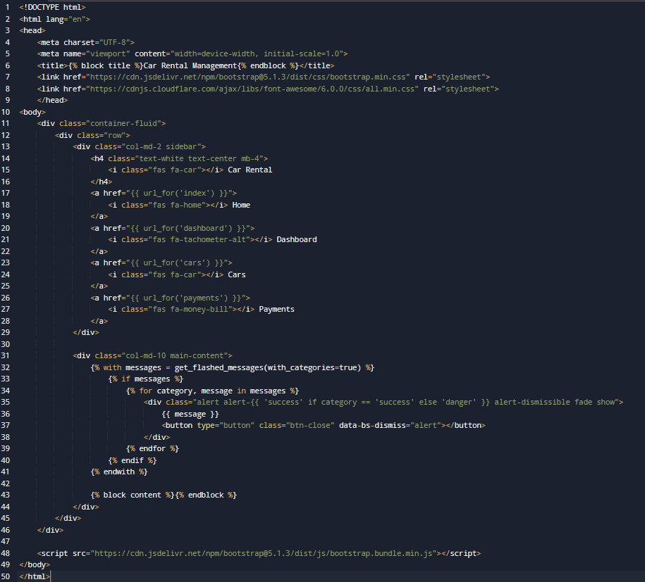

2. "Read" Operation (Dashboard)

This section demonstrates a complex "Read" operation. The backend route fetches multiple data points from the database, and the frontend template renders them in metric cards and an activity feed.

2.1. app.py (Dashboard Data Fetching)

The /dashboard route executes multiple SQL queries to get key business metrics (e.g., total cars, total revenue) and recent activities. This shows data aggregation and preparation for the view.  
  
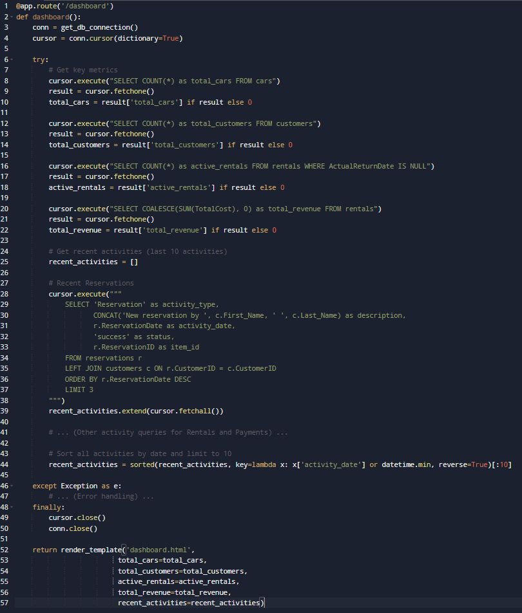  
2.2. dashboard.html (Data Rendering)

The template uses the variables passed from Flask (total\_cars, recent\_activities) to dynamically display the data.

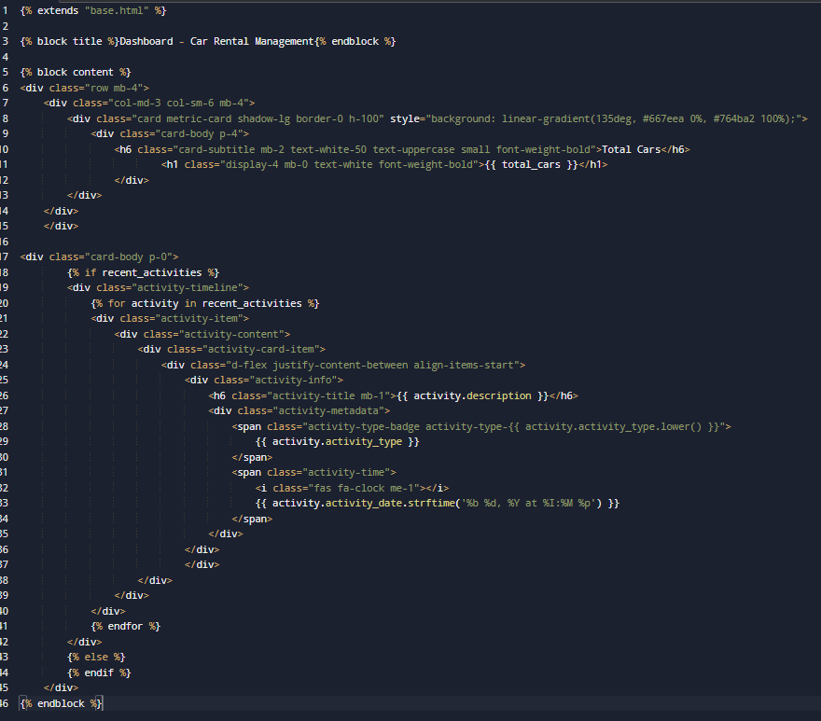

3. "Create" Operation (Add Car)

This section shows the "Create" part of CRUD. The route handles both displaying the form (GET) and processing the submitted form data (POST).

3.1. app.py (Add Car Route)

The add\_car route fetches a list of branches to populate a dropdown (on GET) and inserts a new record into the cars table (on POST).  
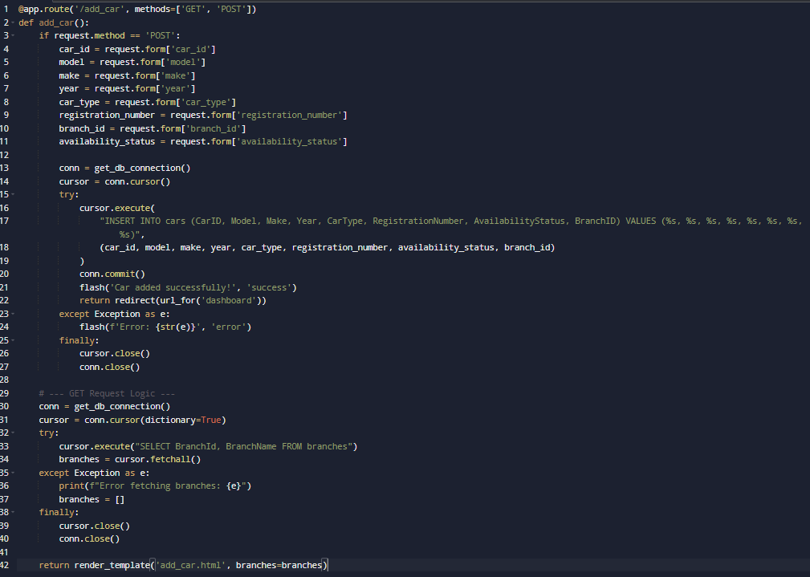

3.2. add\_car.html (Add Car Form)

This template renders the HTML form. It uses a Jinja2 for loop to dynamically create <option> tags for the "Branch" dropdown menu, using the branches list passed from the backend.  
